PLEDGE SHEET

* Please bring this pledge form and money to the registration area on February 4th at City Limits East Lansing
* Bowl-A-Thon sponsors may pledge per pin or a straight dollar pledge for three games of bowling. A minimum of $30 in
pledges per bowler is suggested, but more is encouraged. The bowler who collects the most pledges will win a prize!
* Please make checks payable to Hannah’s House
* Questions? Call 517-482-5856 OR e-mail hannahshouselansing@gmail.com

Participants Name: _________________________________ Address _____________________ City ____________________ Zip ____________

Sponsor’s Name | Complete Address | Phone | Pledge | Total Collected

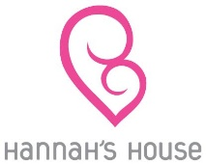
Thank you! Your efforts are greatly appreciated and will help the Hannah’s House Ministry. God bless.

